**APPENDIX I**

**AMAN HEALTH CARE: DOCTOR'S CLINIC WEBSITE DESIGN**

**A PROJECT REPORT**

***Submitted by***

**SAMAR ADIL**

***in partial fulfillment for the award of the degree***

***of***

**BACHELOR OF TECHNOLOGY**

**IN**

**COMPUTER SCIENCE ENGINEERING**



**Lovely Professional University, Punjab**

**12415305**

**OCTOBER 2024**

**APPENDIX II**

**Lovely Professional University, Punjab**

**BONAFIDE CERTIFICATE**

Certified that this project report **“AMAN HEALTH CARE: DOCTOR'S CLINIC WEBSITE”**

is the bonafide work of “**SAMAR ADIL”**

who carried out the project work under my supervision

**SIGNATURE**

**GAURI THAKUR**

**ABSTRACT:**

AMAN HEALTH CARE : THE WEBSITE IS DESIGNED AS A SIMPLE, USER-FRIENDLY INTERFACE FOR A DIGITAL HEALTHCARE PLATFORM. THIS PLATFORM PROVIDE EASY ACCESS TO HEALTH AWARENESS RESOURCES, SERVICES, LAB TESTS ,AND DOCTOR CONSULTATION OPTION. THE DESIGN PRIORITZES EASE OF NAVIGATION, VISUAL APPEAL, AND RESPONSIVENESS TO ENGAGE USERS, ESPECIALLY IN A HEALTHCARE SETTING.

THE DOCTOR'S CLINIC WEBSITE PLATFORM IS DESIGN TO BE A COMPREHENSIVE DIGITAL HEALTH CARE INTERFACE, OFFERING USERS STREAMLINED ACCESS TO ESSENTIAL HEALTH SERVICES AND INFORMATION.

THIS PLATFORM AIMS TO BRIDGE THE GAP BETWEEN PATIENTS AND HEALTHCARE PROVIDERS BY OFFERING MULTIPLE FUNCTIONS IN A SINGLE USER-FRIENDLY SPACE. IT INCLUDES RESOURCES FOR HEALTH AWARENESS, SERVICE SUCH AS BOOKING APPOINTMENTS AND PURCHASING MEDICINES , ACCESS TO SPECIALIST DOCTORS, AND AN EXTENSIVE SECTION FOR LAB TESTS LIKE BLOOD AND ALLERGY SCREENINGS. ADDITIONALLY, THE PLATFORM SUPPORTS VARIOUS HEALTH QUERIES, ALLOWING PATIENTS TO CONSULT EXPERT RESOURCES IN FIELDS SUCH AS CARDIOLOGY, DERMATOLOGY, AND NEUROLOGY. THROUGH INTUITIVE

NAVIGATION AND A RESPONSIVE DESIGN, THIS WEBSITE MAKES HEALTHCARE INFORMATION MORE ACCESSIBLE, ENCOURAGING PROACTIVE HEALTH MANAGEMENT AND SUPPORTING PATIENTS IN MAKING INFORMED DECISIONS REGARDING THEIR WILL-BEING.

Page- 4

Page- 5

**APPENDIX**  IV

**TABLE OF CONTENTS**

|  |  |  |
| --- | --- | --- |
| **CHAPTER NO.** | **CHAPTER NAME** | **PAGE NO.** |
|  | **Title Page** | **1** |
|  | **Bonafide Certificate** | **2** |
|  | **Abstract** | **3-4** |
|  | **Table of Contents** | **5** |
| **1** | **Chapter 1** | **6-7** |
| 2 | **Chapter 2** | 11-17 |
|  | **Conclusion** | 18 |
|  | **References** | 18 |

|  |  |  |  |
| --- | --- | --- | --- |
|  |  |  |  |

**CHAPTER 1**  
   
**INTRODUCTION :**

* The Doctor's Clinic website is a dedicated digital platform focused on enhancing patient access to healthcare services and information. This web interface is designed to meet the needs of a modern healthcare environment, providing users with essential tools to manage their health conveniently. From scheduling appointments and exploring health services to connecting with healthcare professionals and purchasing medicines, this website serves as a one-stop resource for various medical needs. It also emphasizes health education by offering awareness posts on topics like nutrition, mental health, stress management, and preventive care. With its clean, user-friendly design, responsive layout, and interactive elements, the Doctor's Clinic website aims to make healthcare accessible and straightforward, empowering users to take charge of their health.
* The Doctor's Clinic website is a holistic digital healthcare platform designed to make medical services and health information readily accessible to users. Created with simplicity and user engagement in mind, this platform brings together a wide range of resources under one roof. Patients can book appointments, access information on health services, connect with doctors, and explore lab test options effortlessly. Additionally, the website promotes wellness through educational posts on topics such as regular exercise, nutrition, mental health, and sleep quality. The goal of the Doctor's Clinic website is to offer a seamless healthcare experience by combining essential medical resources with an informative, interactive, and visually appealing interface, helping users prioritize and manage their health effectively.

Page- 7

LANGUAGES USED:

The *Aman Health care* project is built using a combination of HTML and CSS providing a seamless and visually appealing user experience.

HTML (Hyper Text Markup Language) serves as the backbone of the website, structuring the content and defining the layout of each page.

CSS (Cascading Style Sheets) is used to style and enhance the visual presentation, ensuring that the website is both aesthetically pleasing and easy to navigate.

Page NO. - 8

OBJECTIVES:

1. Enhance Accessibility: To provide patients with a user-friendly platform that simplifies access to healthcare services, making it easier to find information and book appointments online.

2.Promote Health Awareness: To educate users about various health topics, encouraging proactive health management through awareness posts that cover nutrition, mental health, exercise, and preventive care.

3.Streamline Services: To integrate multiple healthcare services in one location, allowing users to seamlessly navigate between booking appointments, purchasing medicines, and accessing lab test results.

4.Facilitate Doctor-Patient Interaction: To create a bridge between patients and healthcare professionals, enabling users to easily consult doctors and specialists for their medical concerns.

issues, fostering a culture of preventive healthcare among users.

5.Maintain Data Security: To ensure the privacy and security of user information, building trust and confidence in the digital healthcare platform.

By achieving these objectives, the Doctor's Clinic website aims to become a leading digital resource in the healthcare sector, empowering users to take charge of their health and well-being. Page No. – 10

**CHAPTER 2**

CODES:

INDEX.HTML and CSS

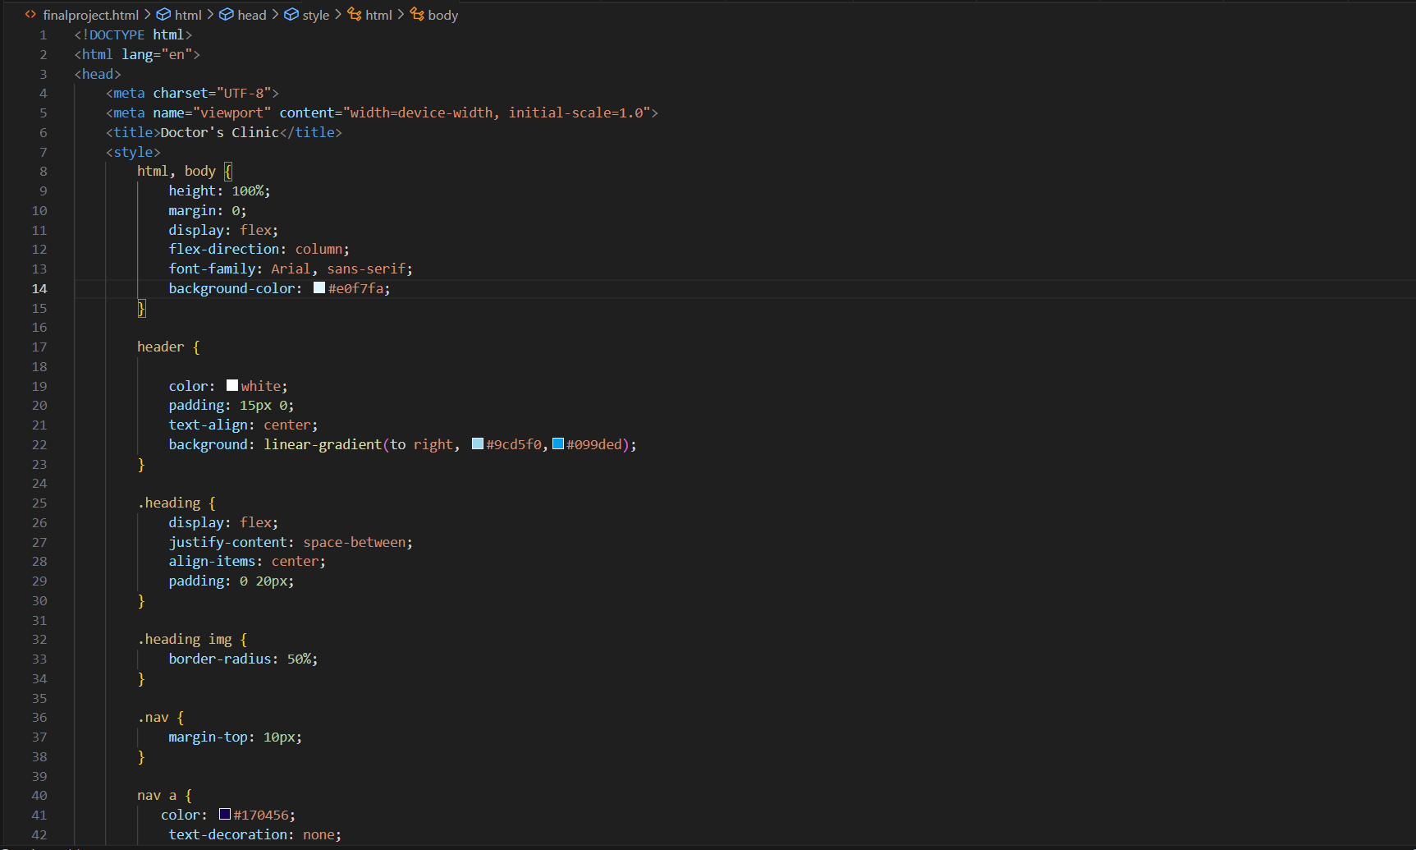

Page -11

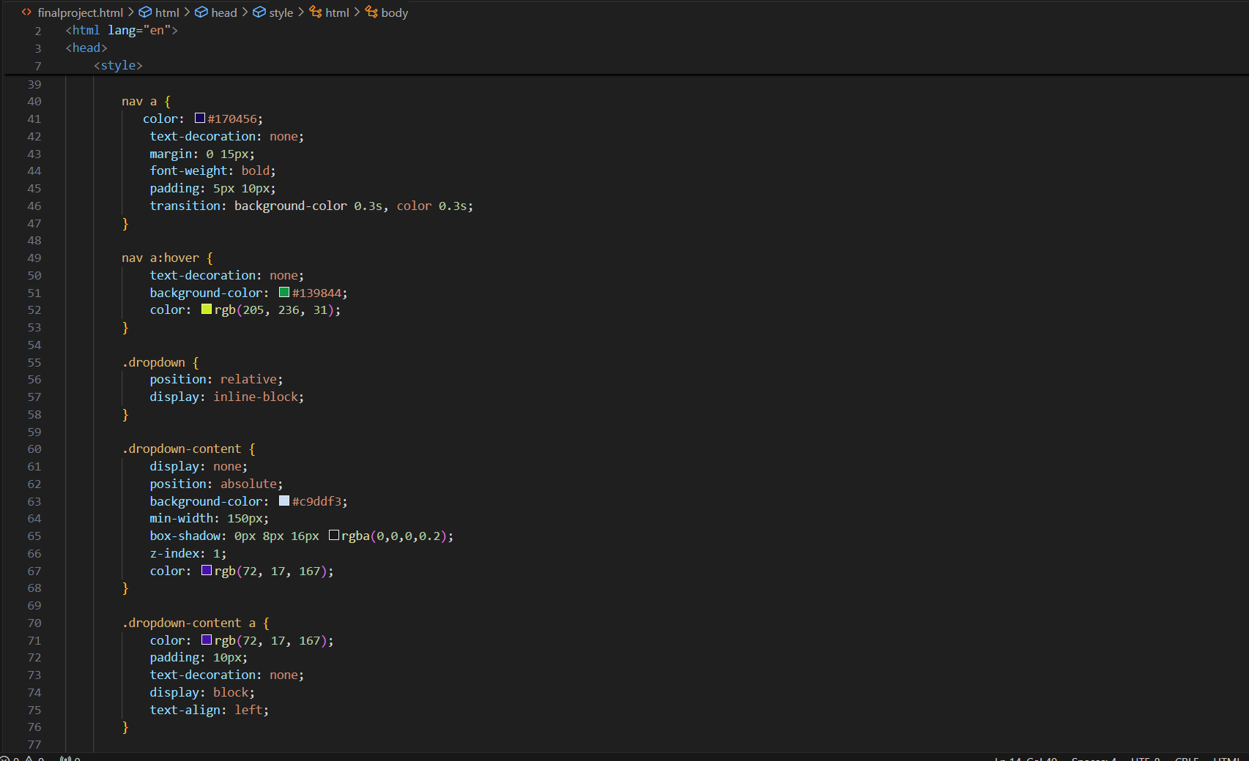

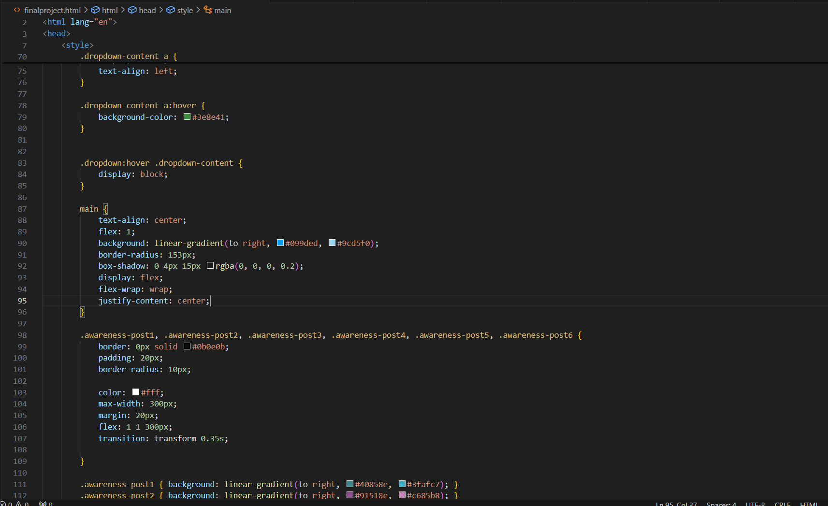

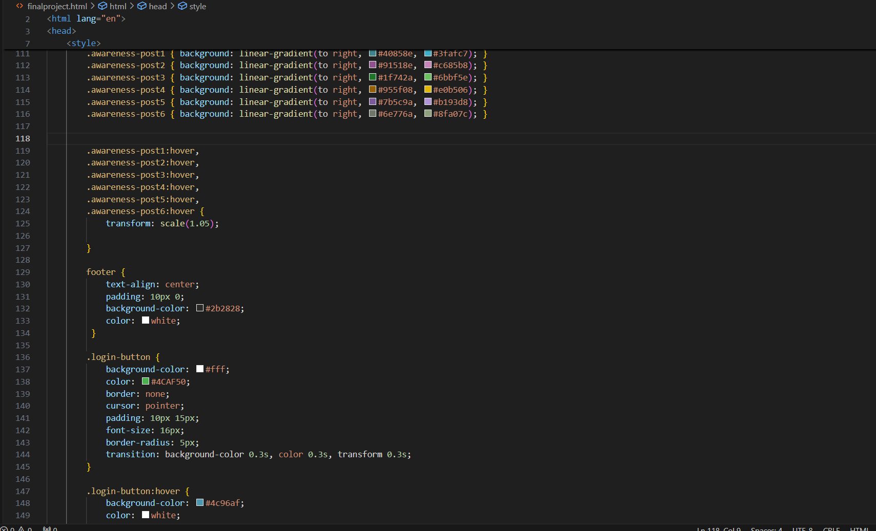

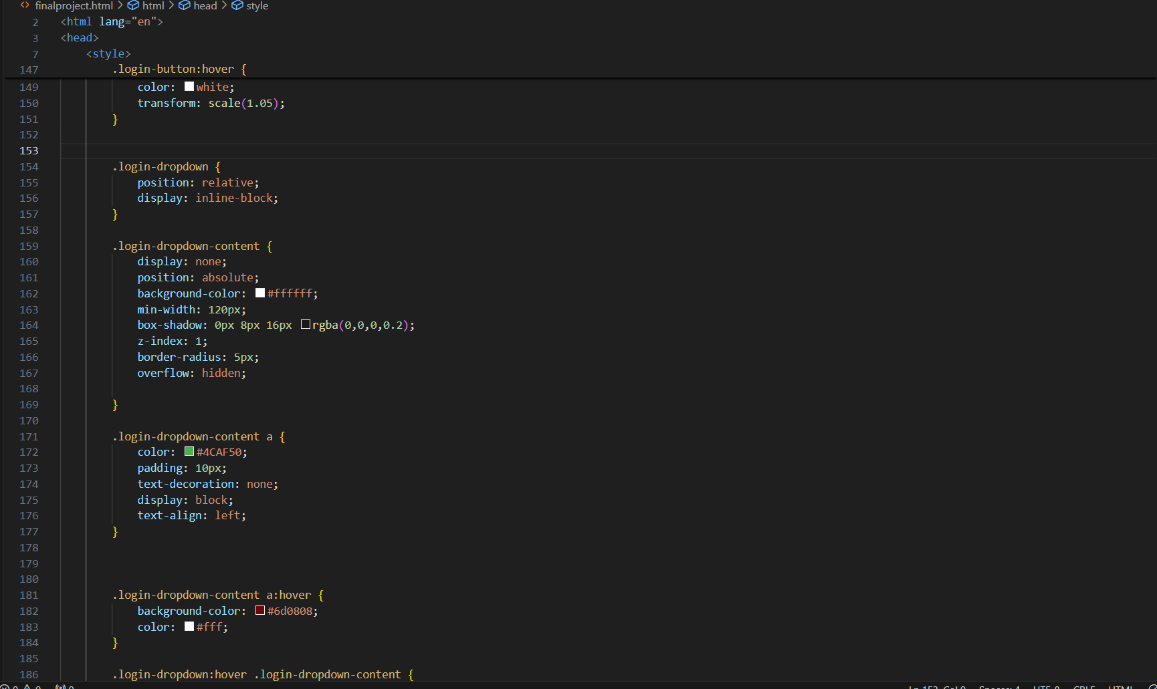

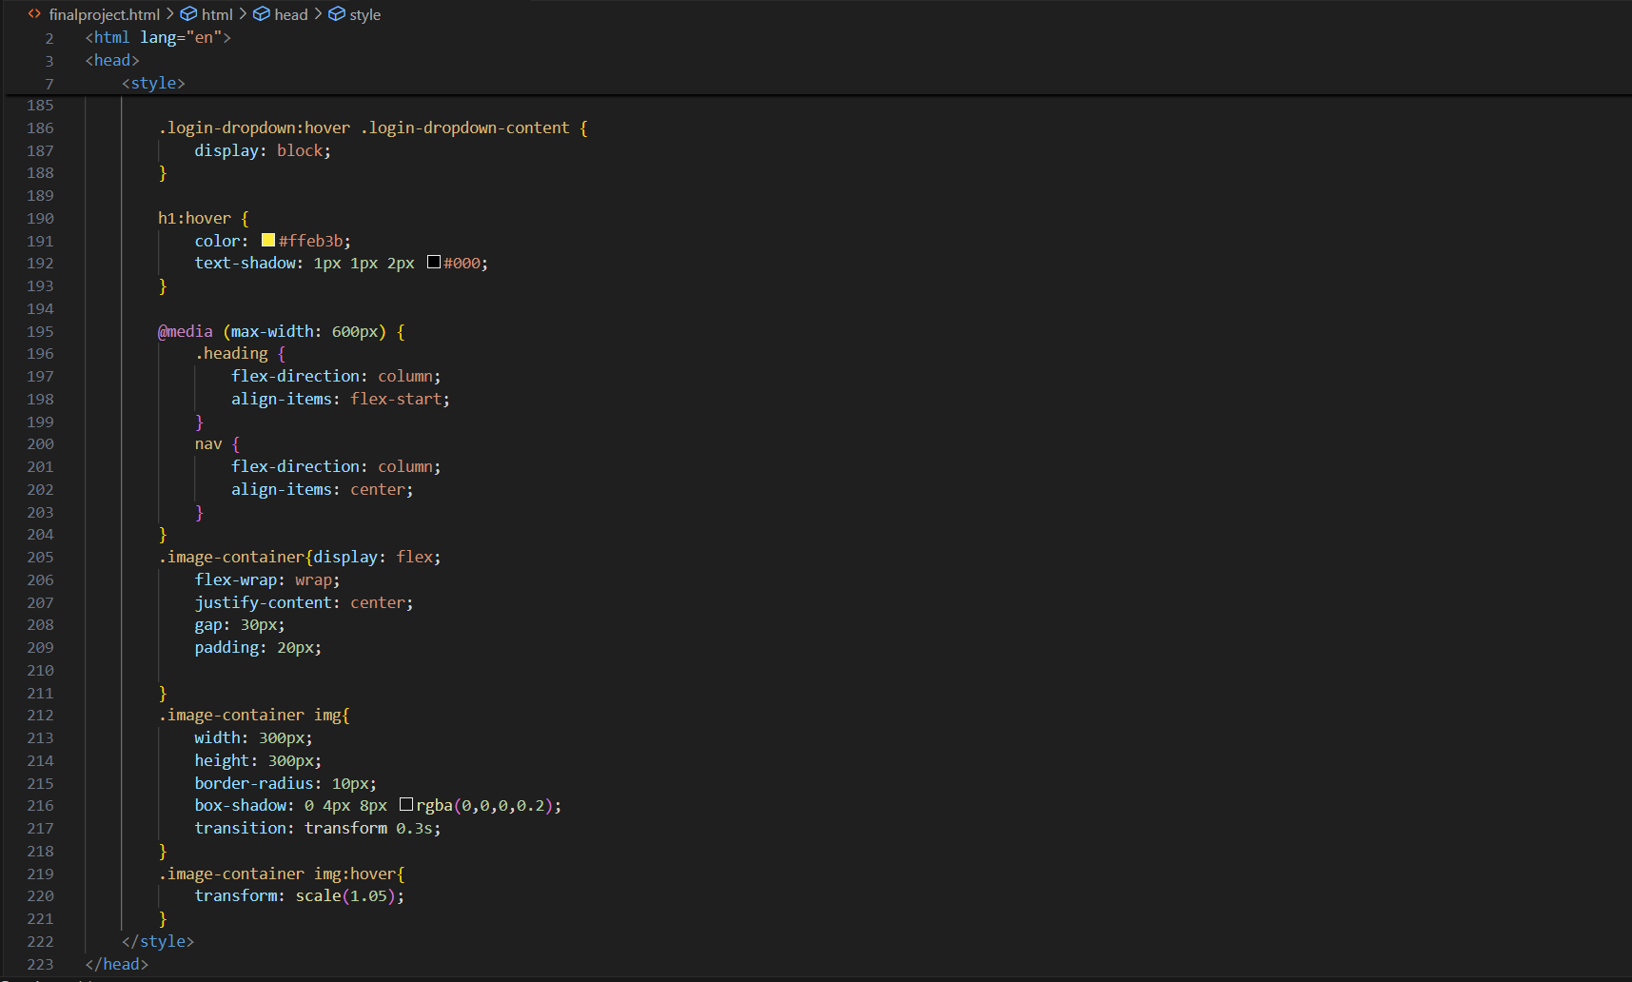

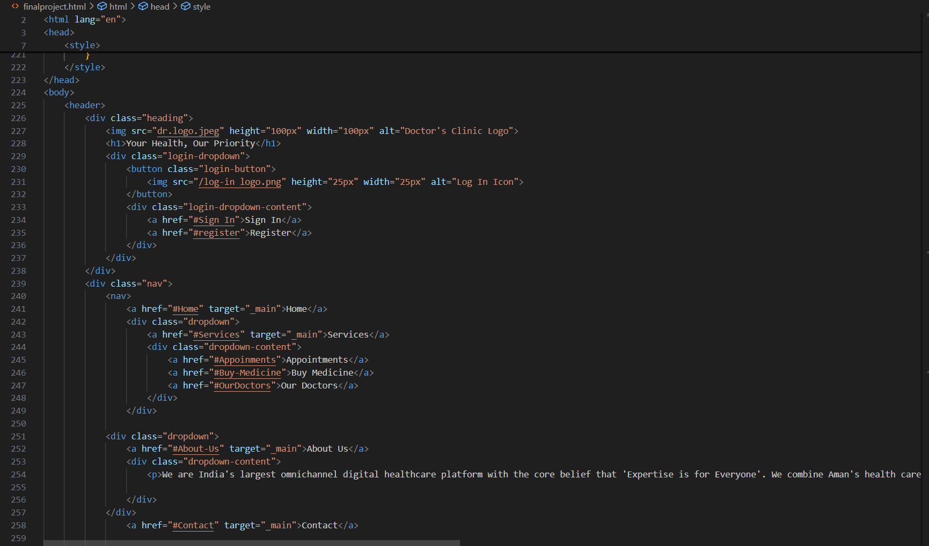

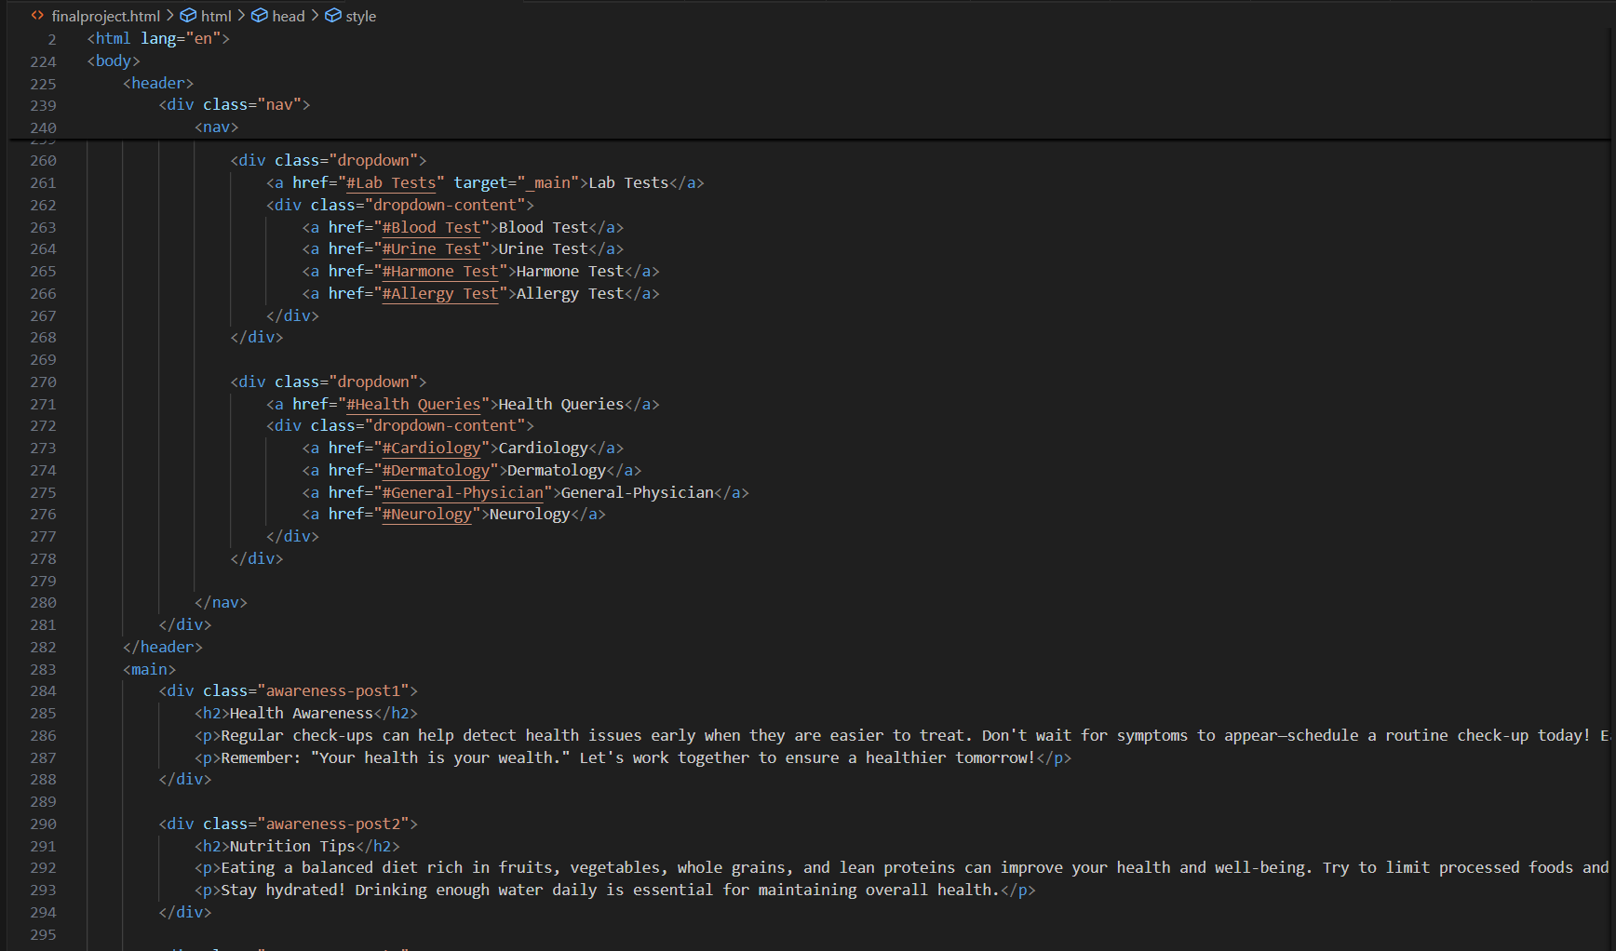

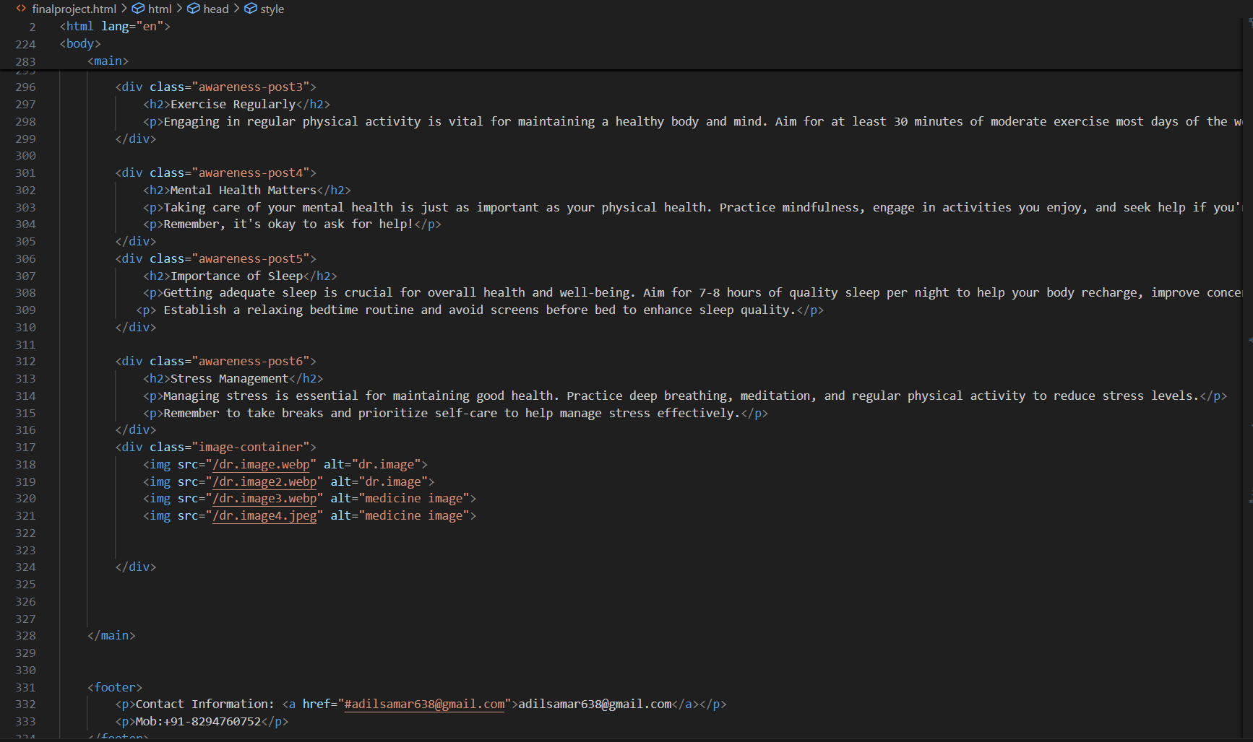

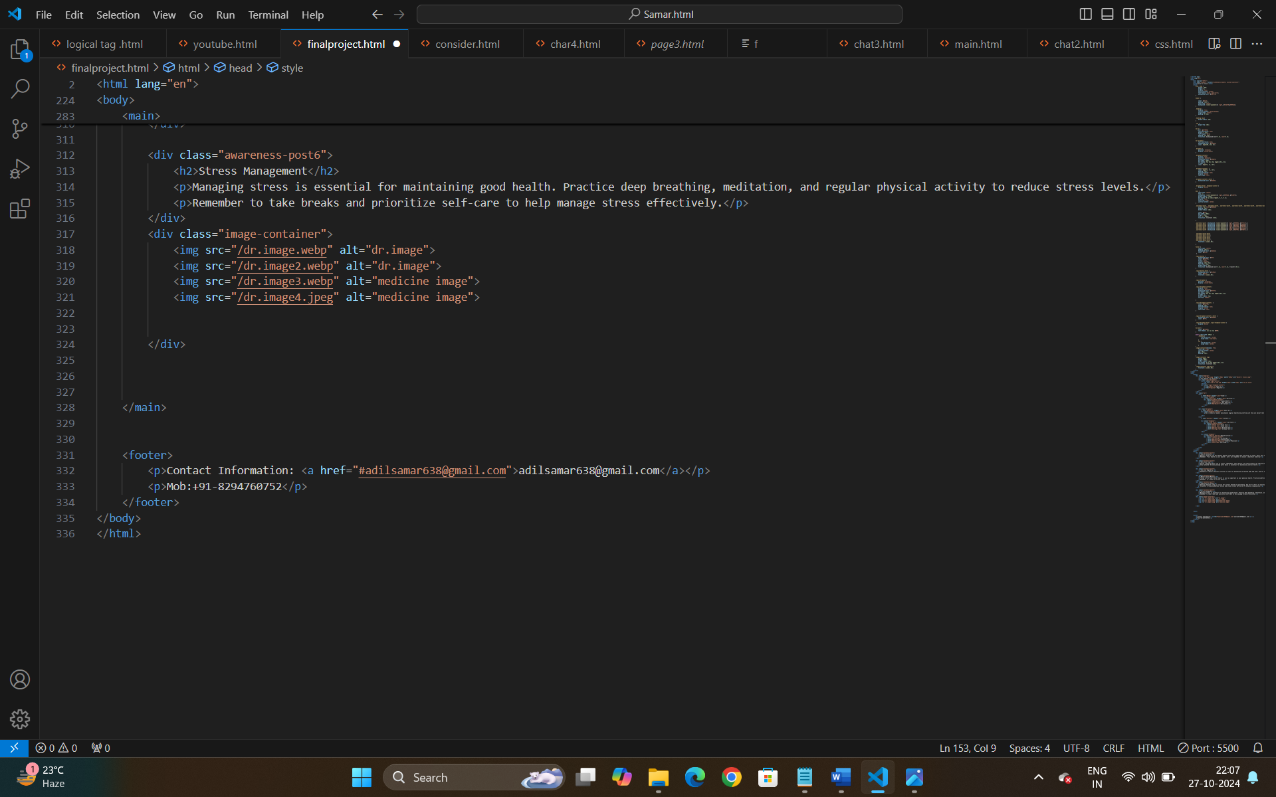

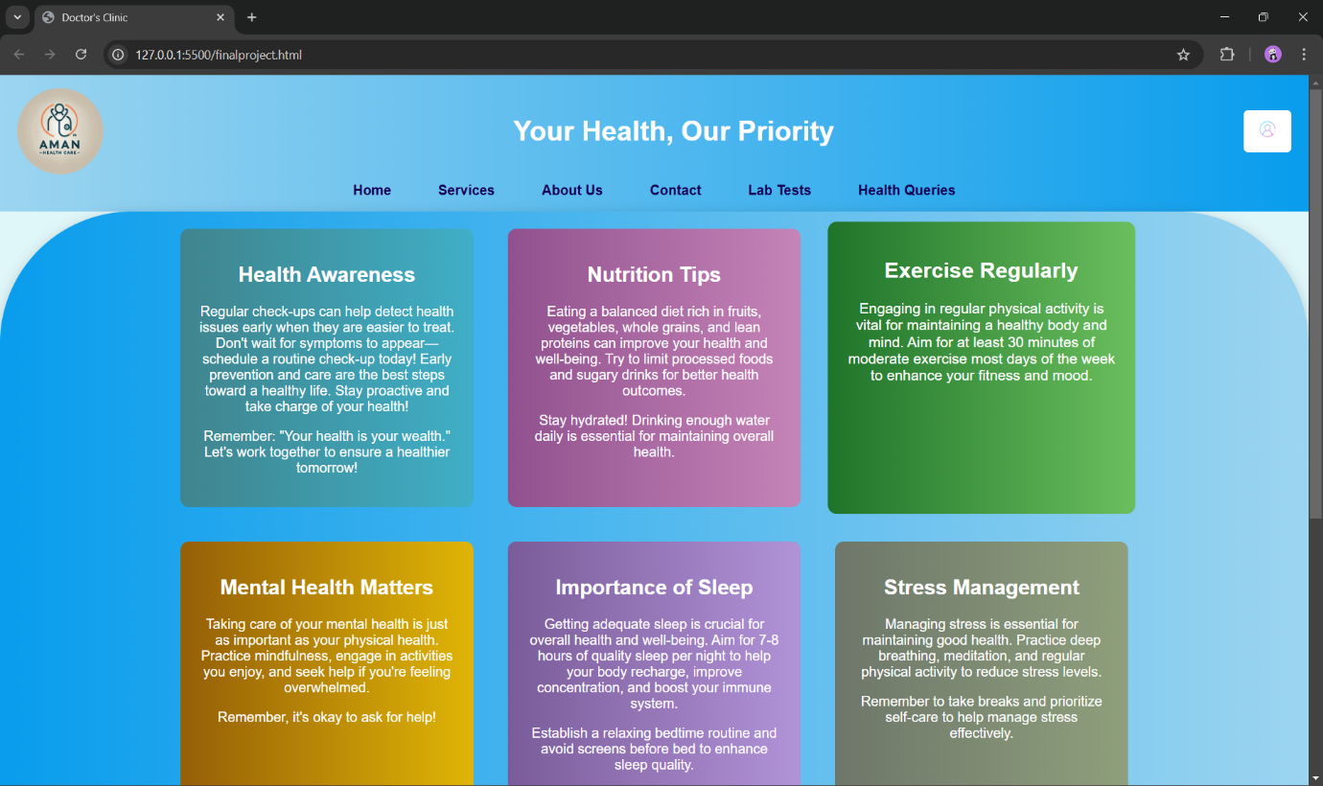

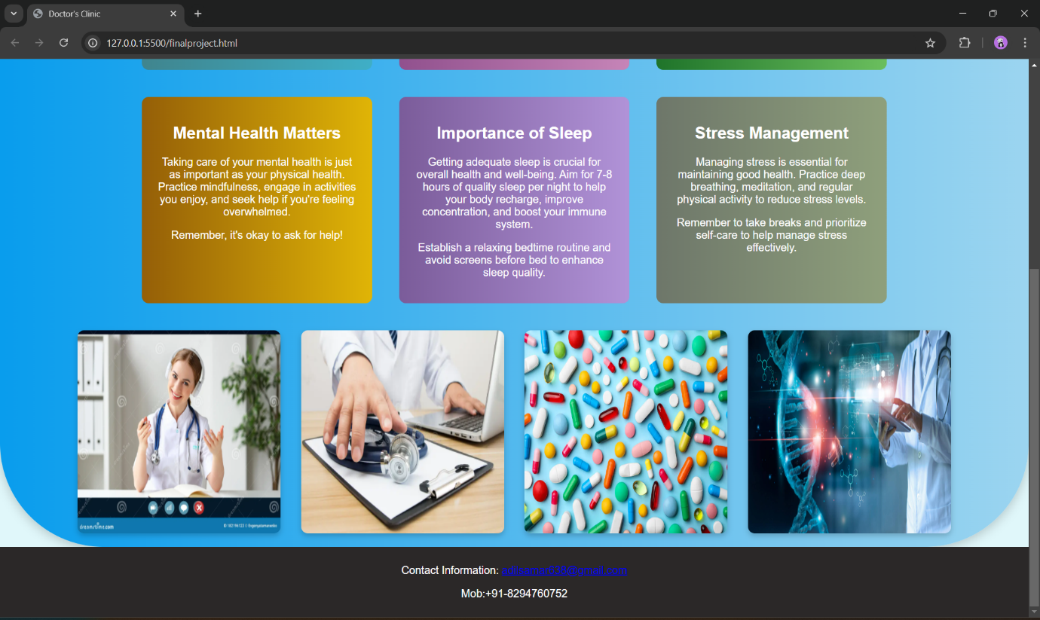

Page - 17

Page - 18

CONCLUSION:

"I believe this document will provide valuable insights into my project. I used a unique approach, which has made learning HTML and CSS more manageable and effective for me. I am determined to keep improving it step by step."

REFERENCES:

<https://www.w3schools.com/>

[https://codewithharry.com](https://codewithharry.com/)

[www.youtube.com](http://www.youtube.com/)

THANK YOU